天橙具身 Robotic Experience

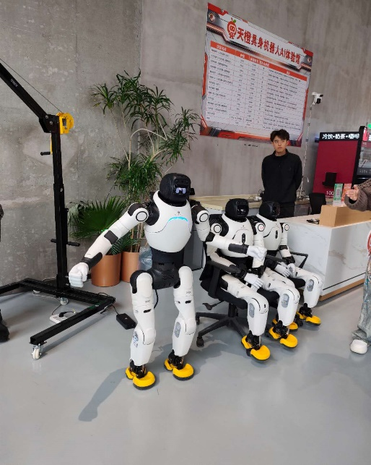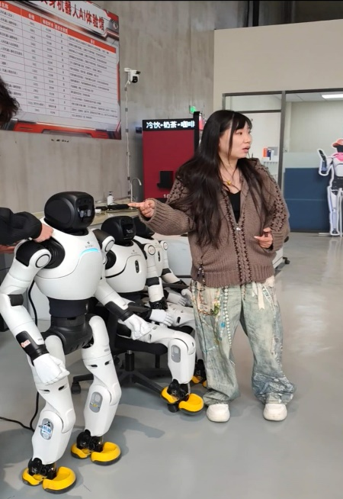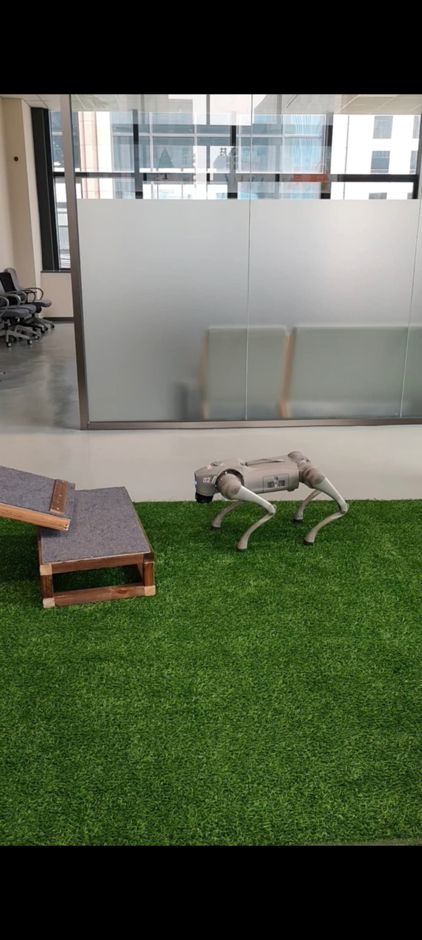

During my visit to the 天橙具身 Robotic Experience Center, I was amazed by the advanced robotics technology on display. The humanoid robots, capable of walking, talking, dancing, and even mimicking human movements, demonstrated impressive agility and precision. I had the chance to control the robots, guiding them through obstacle courses, making the experience interactive and engaging. Beyond entertainment, the robots' potential real-world applications, such as firefighting and security patrols, were highlighted, showing their ability to improve safety and efficiency. The visit also made me reflect on the future of robotics and the possibility of robots replacing humans in various fields. While robotics holds great promise, I believe robots should be used for tasks that are too dangerous or complex for humans, rather than simply imitating us.
The center itself was a blend of innovation and creativity, with robots designed to be both functional and visually appealing. The playful robot designs, including colorful characters, added an element of fun, which made the experience enjoyable for people of all ages. It was clear that the creators of these robots are not only focused on their practical applications but also on making them accessible and entertaining for the public. This combination of technology and entertainment suggests a future where robots will play a central role in various aspects of our lives, from safety to leisure.

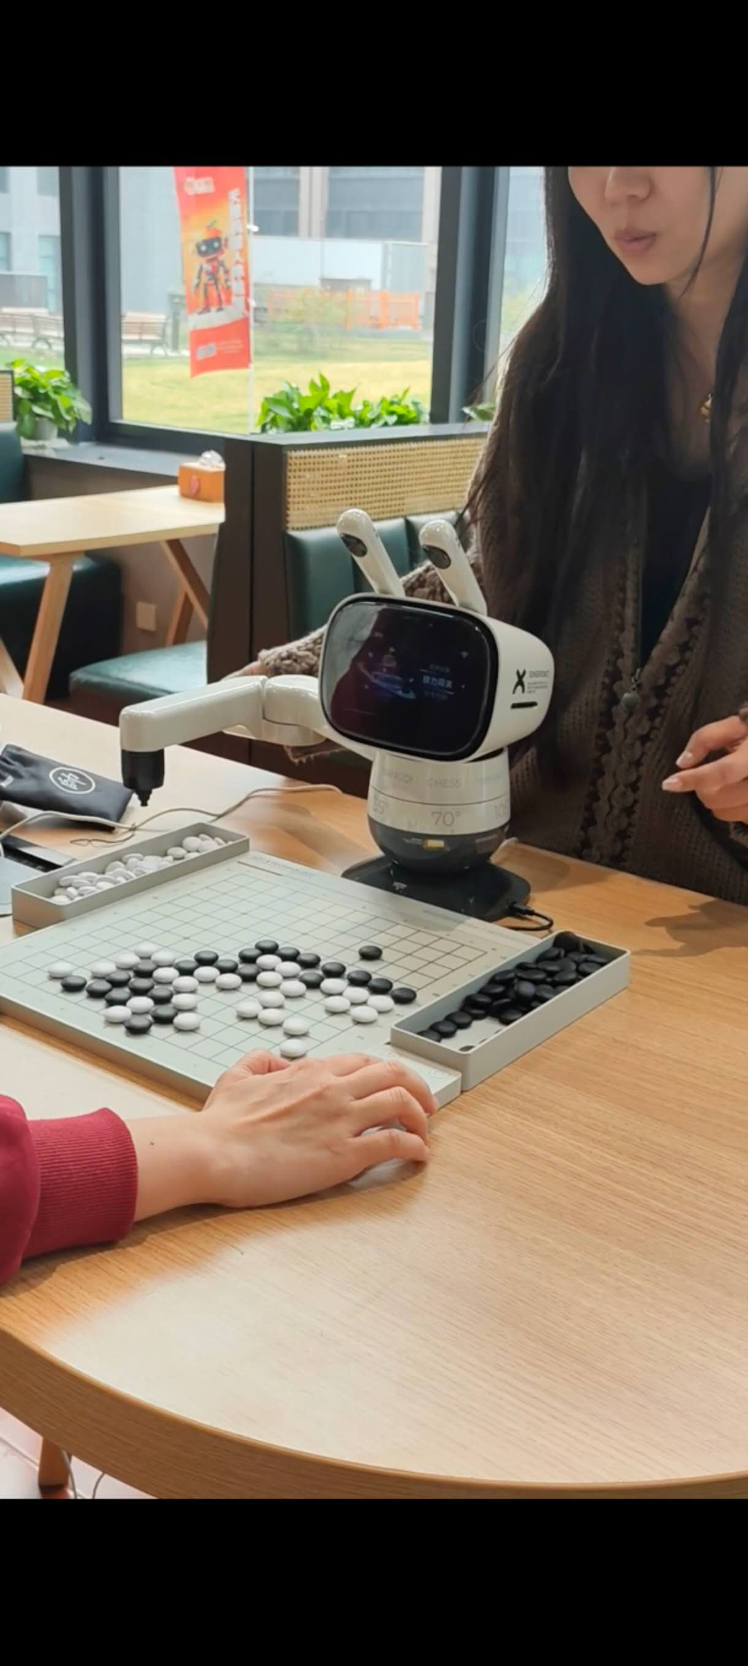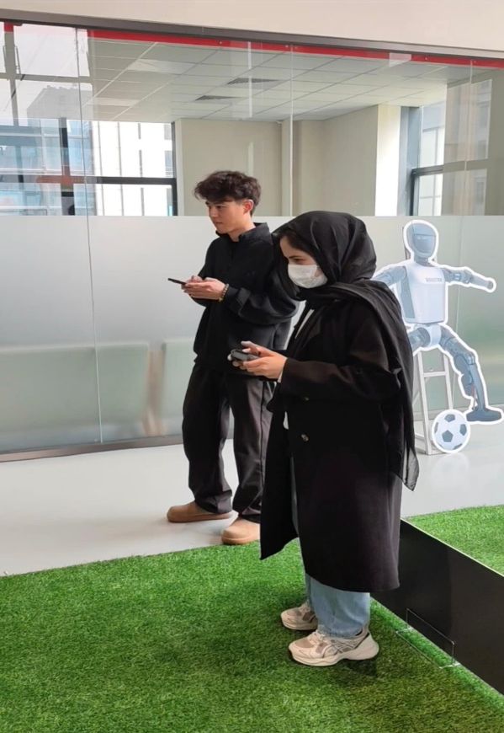

This experience reminded me of how rapidly technology is evolving, especially in China, and how imagination remains the key to unlocking new possibilities. I’m grateful for the opportunity to witness the future of robotics firsthand, and I look forward to seeing how these innovations continue to shape our world.
Sana Zeb, Pakistan

