天橙具身 Robotic Experience
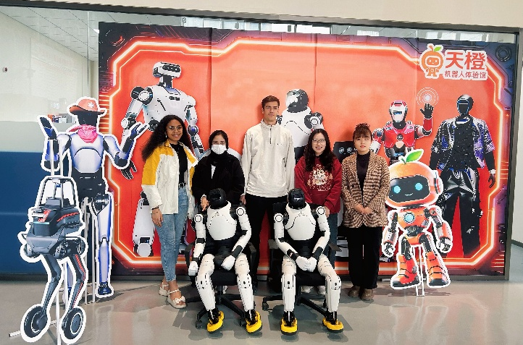
Today, we visited the 天橙具身 Robotic Experience Center, where we immersed ourselves in a fascinating aspect of the technological world by interacting with robots.
During the visit, we witnessed how far technology has advanced. We observed the wide range of movements, tasks, and actions that robots are capable of performing. They can walk, talk, dance, wave their hands, jump, and even imitate human dance moves. We also had the opportunity to control them ourselves, guiding them through various paths with obstacles, which made the experience even more engaging and interactive.
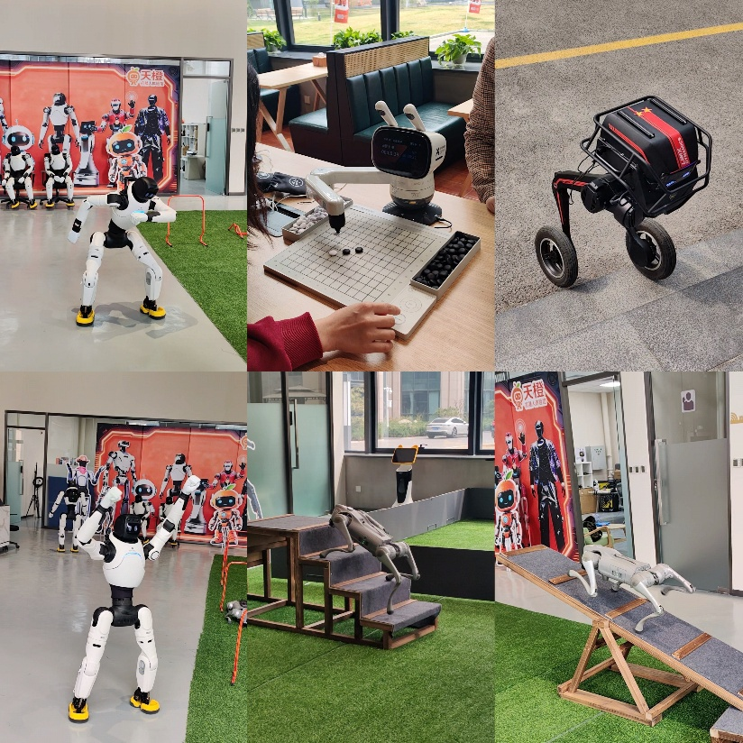
It was explained that these robots can be applied in real-life situations, which I found particularly impressive. For example, they can assist in dangerous scenarios such as firefighting, where their use could significantly reduce the risk to human life while increasing efficiency. They could also be used for night security patrols. From an entertainment perspective, their ability to dance and sing opens up possibilities such as robotic performances or even concerts.
Personally, I found this experience extremely thought-provoking. It made me reflect on how far technology can continue to evolve and what impact it may have on human labor. Will robots eventually replace humans? Will they be able to perform every task as well as—or even better than—humans? These are questions that many people are asking as technology continues to progress.
At the same time, it is clear that human capabilities have limits. In my view, robots should be used to accomplish tasks that are difficult, dangerous, or impossible for humans, rather than simply to imitate them. From what I observed today, this future already seems to be taking shape.
I am consistently impressed by the rapid advancement of technology in China, and it amazes me more every day. I greatly enjoyed today’s experience, which reminded me that the only real limit is our imagination. This visit has shown that we can always continue to push the boundaries of what is possible.
I am very grateful for today’s experience.
RABIALAHY Harivola Kantosoa

